Mixed Media Syllabus

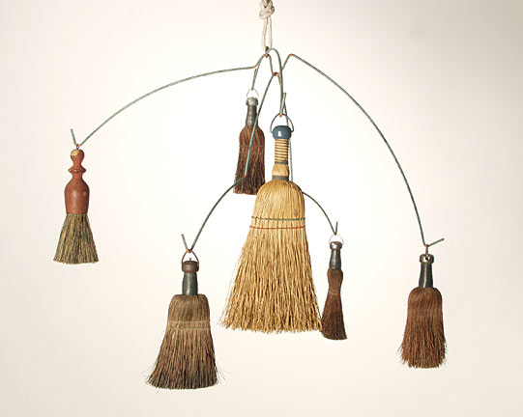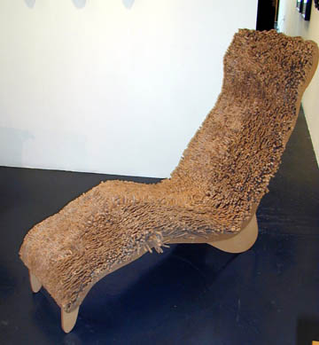

The mixed media class aims to examine the place of material in contemporary art practice. Students will work with new material including but not limited to traditional crafts, fibers, building materials, found objects, nature, trash etc.

Through research and development processes, problem solving, and the use of elements and principles of design, students will create a small body of work.

The class focus will not only be on the creation of artwork but also on the process of completing successful artwork. Students will start with successful planning, followed by production, analysis, and finally documentation of their artwork.

Grading

Your grade will be dependent on the completion and compliance to the directives listed below.

- Daily participation

- Minimum of 3 assignments completed including: (50 points each assignment)

- a full pre-project write-up, including sketches (20pts)
- completed project (50pts)
- neatness and craftsmanship (10pts)
- attention and effort toward the project (10pts)
- successful completion of listed requirements (5pts)
- inclusion of elements and principle of design (5pts)
- post-project write up (20pts)
- class presentation and critique of own artwork (10pts)

Some Expectations
-Be respectful and considerate to others
-Be a cooperative learner
-Ask for help when needed, offer help when possible
-Stay on task
-Be responsible (for your actions and materials)
-Be on time

Classroom Procedures/Routines

The following procedures were created in order to facilitate learning through creating an orderly, respectful atmosphere. If you have any questions, please feel free to discuss them with me.

I intend to be consistent and fair. I take the respect code very seriously and would like everyone to read and abide by it.

Upon Entering Class

The expectation is that when you enter the classroom and there is an assignment already introduced, you will get your supplies and begin working. If there is a new lesson to be presented, please sit quietly in your seats.

Attendance/Tardies

If you are not in the room when the bell rings, you are tardy.
Over 5 minutes late = an absence.

PA Announcements
As with all cases of someone speaking, I expect we will respect the person delivering the announcement. This also includes anyone who holds the floor whether it’s the teacher, your peers, or a person on the TV or Projector. Out of respect, please remain quiet while giving the speaker your full attention.

Collecting and Returning Work
Work is submitted in two ways:
Hard copies are submitted in to the bins located at the front of the room.
Electronic assignments will be posted on the group’s webpage on our class weebly website.

Makeup Work/Late Work
If your absence is excused, you will have a reasonable amount of time to submit work for full credit. Class time may not be used to complete late work unless approved by the teacher.

You may always submit late work for partial credit if the work is done well and complete.

Computer Use

-Absolutely no food or drink at the computers. If you need food or drink within the classroom, it must be kept on the floor.
-Computers should be started at the beginning of the hour and each student should log off/shut down at the end of each hour.
-Absolutely no use of Facebook or other inappropriate websites!
-Free time for checking email will be the first five minutes of class and last 5-10min. of class.

Cell Phones
-There should be no cell phones visible, heard, or used in the art room. Cell phones will be taken on the first offense.

Supplies
Students should come to class every day with the following:
-1” three ring binder for handouts (can be stored in the classroom)
-Lined paper or Sketch book for notes and sketches
-a writing utensil
-Thumb drive for backing up and storing work (very important)

Optional Supplies
-access to a digital camera (to document creation of art)

